
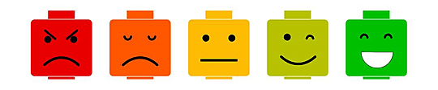
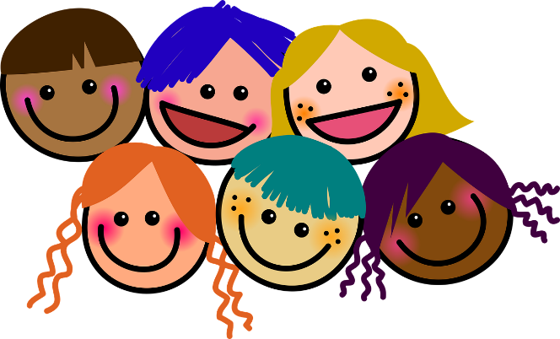
Marvellous Me!
Week 1 + 2  2nd September  9th September  Establishing Weeks | Week 3  16th September  Establishing Weeks | Week 4  25th September  Establishing Weeks | Week 5  30th September  Families | Week 6  7th October  Celebrating Individuality | Weeks 7  14th October  Making Friends | Weeks 8  21st October  Feelings & Emotions
Baseline Assessments  Introduce different areas of the classroom. Model use of resources and how to tidy away.  Start PSHE | Introduce & Start White Rose Maths, P.E & Music  Wellcomm Assesments  Introduce different areas of the classroom. Model use of resources and how to tidy away | Introduce & Start Monster Phonics & R.E  Wellcomm Assesments  Send Tapestry Memo - Add family photo | Introduce & Start Drawing Club  Reading books sent home x 2 Monster Phonics Books  Send Tapestry Memo- Add baby photo
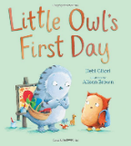  Key Stimulus:  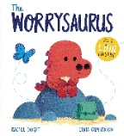 | 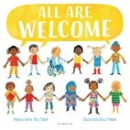  Key Stimulus: | 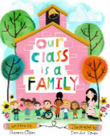  Key Stimulus: | 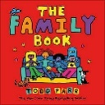  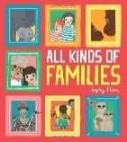  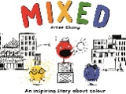  Key Stimulus: | 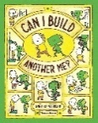  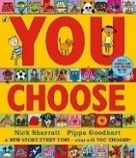  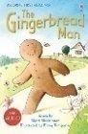  Key Stimulus: | 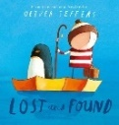  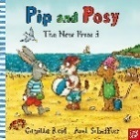  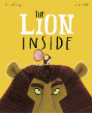  Key Stimulus: | 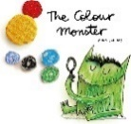  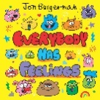  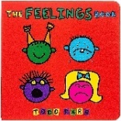  Key Stimulus:
Nursery Rhyme/Song:  Nursery Rhyme Focus | Nursery Rhyme/Song:  Nursery Rhyme Focus | Nursery Rhyme/Song:  Nursery Rhyme Focus | Nursery Rhyme/Song:  Nursery Rhyme Focus | Nursery Rhyme/Song:  Nursery Rhyme Focus | Nursery Rhyme/Song:  Nursery Rhyme Focus | Nursery Rhyme/Song:  Nursery Rhyme Focus
Role Play: Home


C&L:
Listening, Attention & Understanding:
- Enjoys listening to longer stories and can remember much of what happens.
- Pays attention to more than one thing at a time.
- Uses a wider range of vocabulary.
- Understands a question or instructions that has two parts.
- Understands ‘why’ questions.
- Understands how to listen carefully and why listening is important.
- Learns new vocabulary
- Listens carefully to rhymes and songs
Speaking:
- Can talk about what is happening in stories.
- Sings a large repertoire of songs.
- Knows many rhymes.
- Can talk about familiar books and be able to tell a long story.
- Uses longer sentences of four to six words.
- Can express a point of view.
- Can debate when they disagree with a friend or adult, using words as well as actions.
- Starts a conversation with an adult or friend and can continue it for many turns.
- Uses talk to organise themselves and their play.
- Joins simple sentences with ‘because’, ‘or’, ‘and’.
- Begin to use a range of tenses.
- Uses new vocabulary through the day.
- Engages in story times.
- Retells stories once they’ve developed familiarity with the text.
- Asks questions to find out more and to check they understand what has been said to them
- Develops social phrases.
Listening, Attention & Understanding:  Week 1:  Introduce carpet rules – legs crossed, lips closed, good looking, good listening.  Introduce wiggly fingers when bell/ tambourine is rung.  Week 2:  Learn how to make a circle and sit down. | Listening, Attention & Understanding:  Introduce carpet spaces.  Learn getting ready for home time. | Listening, Attention & Understanding:  Covered throughout other areas of learning.
Speaking:  Week 1:  Learn how to answer the register.  Week 2:  Learn how to greet your friends.  Learn how to speak in full sentences with our friends and ask somebody if we can play with them. | Speaking:  Learn when and how to say please and thank you e.g. when getting our lunch. | Speaking:  Covered throughout other areas of learning.

PSED:
Self-Regulation:

- Become more outgoing with unfamiliar people in the setting.
- Sees themselves as a valuable individual
- Express their feelings
Managing Self:
- Beginning to remember rules without needing an adult to remind them.
- Talks about their feelings using words like ‘happy’, ‘sad’, ‘angry’ or ‘worried’.
- Begins to understand how others may be feeling.
- Be increasingly independent when dressing, undressing and meeting their own care needs
- Make healthy choices about food, drink, activity and toothbrushing
Building Relationships:
- Show more confidence in new social situations.
- Play with one or more other children, extending and elaborating play ideas.
- Talk with others to solve conflicts
- Build constructive and respectful relationships
Jigsaw PSHE:
- I understand how it feels to belong and that we are similar and different
- I can start to recognise and manage my feelings
- I enjoy working with others to make school a good place to be
- I understand why it is good to be kind and use gentle hands
- I am starting to understand children’s rights and this means we should all be allowed to learn and play
- I am learning what being responsible means
Self-Regulation:  Week 1:  Learn how to manage feeling worried or upset about leaving a parent or guardian at the beginning of the day  Week 2:  Read the Worrysaurus and talk about all of the strategies we can use to calm down (going to a quiet space, looking at a book, speaking to an adult or friend). Introduce this as the yellow zone. | Self-Regulation:  Learn and talk about times we are happy and in the green zone. | Self-Regulation:  Practise a mindfulness activity that keeps us in the green zone. | Self-Regulation:  Learn and talk about times we have been angry in the red zone. Discuss and practise a mindfulness activity to help combat our angry emotions e.g. yoga, breathing, reading a book in a quiet space. | Self-Regulation:  Discuss how we know we are tired (blue zone) and learn 3 key strategies that we can re-energise ourselves (drinking water, having a fruit or vegetable snack, exercising). | Self-Regulation:  Revisit soothing and self-regulation strategies throughout the day and use brain breaks for all children regularly.  Explain these using the language of zones of regulation e.g. I can see that lots of us are moving into the yellow zone because I can see people are a bit fidgety, let’s do xyz to help ourselves focus again. |  | Self-Regulation:  Read ‘The Colour Monster’ and ‘The Feelings book’ link back to the zones of regulation
Managing Self:  Week 1:  Show children where the toilet is.  Teach children where their pegs, going home box, book bag box and water bottle tray is.  Week 2:  Learn lining up and walking into the hall for lunch quietly.  Teach child to independently find a peg and place their coat on a peg.  Teach children to place their bookbag in the trolley nicely.  Introduce the schools ‘Golden Rules’. | Managing Self:  Model tidying up using the pictures on labels to put all resources into the correct box/place.  Teach putting lids on all pens and glue sticks.  Teach hand washing and drying hands/using the bins appropriately.  Teach difference between the bin and recycling bin (what go’s where).  Ensure children know where each of the self-selection areas are in the classroom.  Model using them and only taking the things you need/putting back after. | Managing Self:  Learn how to give out and use whiteboards for phonics.  Learn how to put coat on and off properly.  Learn how to take shoes on and put wellies on.  Learn how to put wellies on the welly rack nearly. | Managing Self:  Cooking simple biscuits (gingerbread people cutters) – focus on hand washing and turn taking | Managing Self:  Practising learnt routines throughout the day. Covered throughout other areas of learning.
Building Relationships:  Week 1:  We can tell Reception adults our name.  Week 2:  We can learn the names of at least 5 children in Reception.  We can tell other children our name. | Building Relationships:  We can use grownups names if we want to talk to them  We can join in small group activities. | Building Relationships:  We can play with one or more child.  We can work together to create something in an exciting area of the classroom or outside. | Building Relationships:  Introduce the use of a timer to things such as the iPads or scooters so children know when their turn is finished. | Building Relationships:  Adult interactions to focus on solving conflict and restorative/reflective approach and encourage children to talk about what is happening and how they could resolve this independently (Zones of Regulation)
PSHE- Being Me in My World  Week 2: 1. Who... Me?! | PSHE: Being Me in My World  2. How am I feeling today? | PSHE: Being Me in My World  3. Being at School | PSHE: Being Me in My World  4. Gentle hands | PSHE: Being Me in My World  5. Our Rights |  | PSHE: Being Me in My World  6. Our responsibilities
Key Vocabulary: Kind, Gentle, Friend, Similar(ity), Different, Rights, Responsibilities, Feelings, Angry, Happy, Excited, Nervous, Sharing, Taking Turns
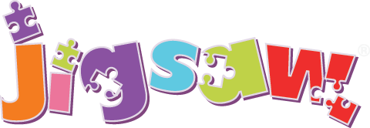
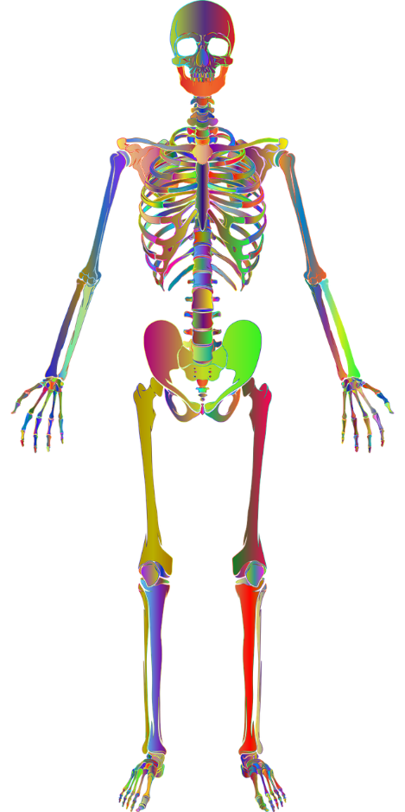
PD:
Gross Motor Skills:
- Can use scooters, trikes or bikes.
- Goes up steps/apparatus using alternate feet.
- Can skip, hop and stand on one leg.
- Can hold a pose like a statue.
- Can use large-muscle movements e.g. wave a flag or streamers.
- Takes part in some group activities which they make up for themselves or in teams.
- Can remember sequences and patterns of movement related to music and rhythm
- They can decide how they travel along apparatus based on their developing physical skills.
- Can choose appropriate resources to carry out a plan.
- Works with others to manage large items e.g. carrying a plank with a friend.
- Demonstrates the ability to roll, crawl, walk, jump, run, hop, skip and climb.
- Use their core muscle strength to achieve a good posture when sitting at a table or on the floor.
- Develop the overall body strength, co-ordination, balance and agility.
- Develop a range of ball skills including throwing and catching.
Fine Motor Skills:
- Uses one-handed tools and equipment
- Uses a comfortable grip with good control for holding pens/pencils.
- Start to eat independently and learning how to use a knife and fork
- Shows a preference for a dominant hand.
- Becomes more independent as they get dressed/undressed.
- Can use a range of tools competently, safely and confidently
Get Set 4 P.E
- Uses movement skills with developing balance and co-ordination.
- Negotiates space safely with consideration for myself and others.
- Demonstrates balance.
- Confidently and safely use a range of large and small apparatus.
- Combine movements, selecting actions in response to the task and apparatus.
- Use movement skills with developing strength, balance and co-ordination showing increasing control and grace.
Gross Motor:  Week 1: Children to have access to obstacle course blocks and bricks in the outdoor provision to carry. Lift and manoeuvre.  Learning how to manoeuvre into a circle and how to get into a straight line.  Week 2: Learning how to take our jumpers off and put them on.  Learning how to put our coats on independently and begin to learn how we can do up a zip/button. | Gross Motor:  Covered in PE lessons and through continuous provision and independent access to resources.
Fine Motor:  Week 1: Children to have access to playdough in the provision with plastic knives and forks.  Week 2: Children will have access to scissors and coloured paper to practise cutting during busy time (model how to use scissors safely) | Fine Motor:  Children to have access to tweezers and pom poms to practise building their fine motor skills. | Fine Motor:  Children will have pegboards as an enhancement to practise building their fine motor skills. | Fine Motor:  Learning which hand feels most comfortable to write with during our phonics lessons. | Fine Motor:  Continued through continuous provision and independent access to resources.
 | Get Set 4 P.E:  Introduction to P.E Unit 2  Theme: People Who Help Us  To move around safely in space. | Get Set 4 P.E:  Introduction to P.E Unit 2  Theme: Friends and Family  To follow instructions and stop safely. | Get Set 4 P.E:  Introduction to P.E Unit 2  Theme: Houses and Homes  To stop safely and develop control when using equipment. | Get Set 4 P.E:  Introduction to P.E Unit 2  Theme: Morning Time  To follow instructions and play safely as a group. | Get Set 4 P.E:  Introduction to P.E Unit 2  Theme: At the Shops  To follow a path and take turns. | Get Set 4 P.E:  Introduction to P.E Unit 2  Theme: Dinner Time  To work co-operatively with a partner.

Key Vocabulary: catch, path, score, direction, rules, space, partner, safely, stop


Literacy:
Word Reading:
- Can spot and suggest rhymes.
- Counts or claps syllables in words.
- Recognises words that have the same initial sound.
- Reads individual letters by saying the sounds for them.
- Blends sounds into words so they can read short words.
- Reads some digraphs.
- Read a few CEWs matched to Monster Phonics
- Reads simple phrases and sentences.
Comprehension:
- Understands that print has meaning.
- Understands that print has different purposes e.g. to warn.
- Knows that we read English from left to right and top to bottom.
- Can name the different parts of a book.
- Knows that pages are sequenced.
- Engages in extended conversations about stories.
- Discusses vocabulary in texts.
- Re-reads books to build up their confidence in word reading, their fluency and their understanding and enjoyment.
Writing:
- Uses some print and letter knowledge in their early writing e.g. writing a shopping list that starts at the top of the page or writing ‘m’ for mummy.
- Writes some or all of their name.
- Writes some letters accurately.
- Form lower-case letters correctly.
Word Reading:  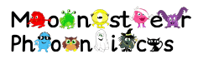  Finding and reading their name card. |  | Word Reading:  See Monster Phonics Planning – S,A,T,P  HFWs – a, at, as | Word Reading:  See Monster Phonics Planning – I,N  HFWs – in, it, is, I, an | Word Reading:  See Monster Phonics Planning – M,D,G  HFWs – and, am, dad | Word Reading:  See Monster Phonics Planning – O,C,K,CK  HFWs – to, into, go, no, the | Word Reading:  See Monster Phonics Planning – E,U,R  HFWs – can, got, on, get, not, cat, dog.
Comprehension:  Week 1&2:  Children to engage in story times with the key weekly texts and daily story time.  Children to discuss their thoughts and feelings of their first week at school using words to describe their emotions. | Comprehension:  To learn to engage in story times and participate without calling out.  To learn to engage in story times and ask key questions about the characters. | Comprehension:  Small world resources alongside a familiar book for children to develop play around the story added to the class Library area. | Comprehension:  Covered in story times.
Writing:  Children to have access to name cards and mark making resources to practise writing their name.  Write their name to go on learning space on the wall. |  |  | Writing:  Introduce children to their sound mats and letter formation sheets available in trays and in provision. | Writing:  Children to have access to the same resources as previous weeks and also sensory trays for children to practise mark making.
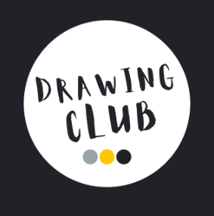 |  |  | Drawing Club:  Key Stimulus:  Vocabulary:  HARMONIOUS  TRIPLE  INTELLIGENT  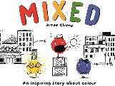  BOASTFUL  SQUABBLE  DIVIDED  UNIQUE  POPULATED | Drawing Club:  Key Stimulus:  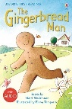  Vocabulary:  LEAP  ACCELERATE  PURSUE  BLOCK  CUNNING  SOGGY  MOCKING  DISAPPOINTED | 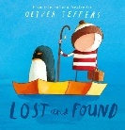  Drawing Club:  Key Stimulus:  Vocabulary:  CONFUSED  ACCOMPANY  DEJECTED  MISPLACED  CONSULTED  MINIATURE  CONSTRUCTED | Drawing Club:  Key Stimulus:  Vocabulary:  DISCOMBOBULATED  INEFFECTUAL  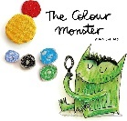  ASSIST  SHIMMERING  SOBBING  ENRAGED  EVAPORATE  TIMID  TRANQUILITY

Maths:
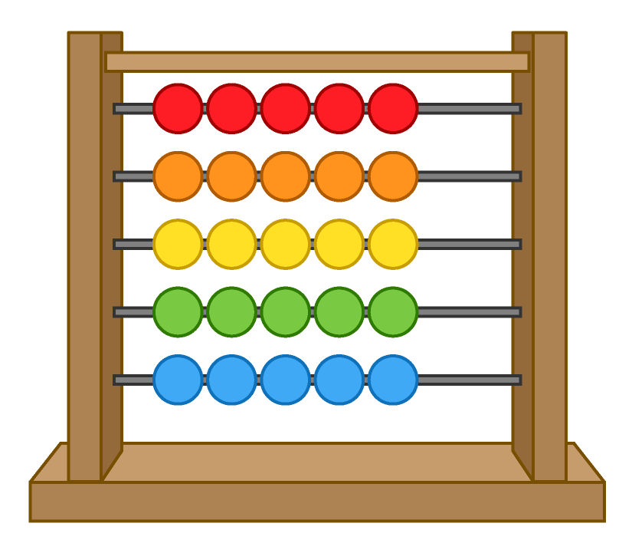
Number:
- Develops fast recognition of up to 3 objects, without having to count them individually (subitising)
- Says one number for each item in order.
- Knows that the last number reached when counting tells how many in total (cardinal principles).
- Experiments with their own symbols and marks as well as numerals.
- Solve real world mathematical problems with numbers up to 3.
- Count objects, actions and sounds up to 3.
- Can automatically recall number bonds to 3.
- Can represent numbers up to 3.
- Can subitise numbers up to 3.
- Can compare numbers up to 3.
- Understands one more than/one less than up to 3.
- Can match two objects together e.g. a pair of socks
- Able to see that objects are the same
- Can identify when things are the same and put them together
- Can create rules to sort objects by
- Can sort objects by type
- Spots patterns in the environment, beginning to identify the pattern “rule”
- Compares two small groups of up to 3 objects, saying when there are the same number of objects in each group.
Shape, Space & Measures:
- Compare, length, weight and capacity of objects and use mathematical language to describe them.
- Explore simple patterns.
- Continue, copy and create repeating patterns.
 | Maths:  Block 1 – Match, Sort & Compare  - Match objects  - Match pictures and objects  - Identify a set  - Sort objects to a type  - Explore sorting techniques  - Create sorting rules  - Compare amounts | Maths:  Block 2 – Talk about Measure & Pattern  - Compare size  - Compare mass  - Compare capacity  - Explore simple patterns  - Copy and continue simple patterns  - Create simple patterns | Maths:  Block 3 – It’s Me 1,2,3  - Find 1, 2 and 3  - Subitise 1, 2 and 3  - Represent 1, 2 and 3  - 1 more  - 1 less  - Composition of 1, 2 and 3
 | Linked Texts:  - A Pair of Socks by Stuart J. Murphy  - Seaweed Soup by Stuart J. Murphy  - The Button Box by Margarette S. Reid  - Beep Beep, Vroom Vroom! by Stuart J. Murphy  Daily Routine:  - Point out to children where objects such as water bottles or book bags belong around the classroom to help with routines of the day.  - At tidy-up time, encourage children to match resources to pictures to ensure that they are put away in the correct place. Where does this belong?  - When lining up during the day, ask children to join the line depending on different attributes, for example, line up if you have a sister. | Linked Texts:  - Where’s My Teddy? by Jez Alborough  - It’s the Bear! by Jez Alborough  - The Blue Balloon by Mick Inkpen  - Dear Zoo by Rod Campbell  - My First Book of Patterns by Bobby and June George  - We’re Going on a Bear Hunt by Michael Rosen  - A-B-A-B-A – A Book of Pattern Play by Brian P. Cleary  Linked Rhymes:  - Big Fish, Little Fish, Cardboard Box  - In and Out the Dusty Bluebells  - Tongue Twister patterns such as Red Lorry, Yellow Lorry  - Clap Your Hands and Wiggle Your Fingers | Linked Texts:  - Anno’s Counting Book by Mitsumasa Anno  - How to Count to One by Caspar Salmon  - Goldilocks and the Three Bears  - The Gingerbread Man  - A Squash and a Squeeze by Julia Donaldson  - The Three Billy Goats Gruff  Linked Rhymes:  - Three Blind Mice  - When I Was One, I Banged My Thumb  - Hickory Dickory Dock  - One Elephant Went Out to Play  - Three Little Speckled Frogs  Three Little Ducks
 | Key Vocabulary:  Match, matching pair, pair, same, different, sort, set, alike, rule, more, fewer, compare   | Key Vocabulary:  Size, length, weight, mass, pattern, big, little, large, small, tall, short, long, smaller, bigger, taller, longer, shorter, heavy, light, heavier, lighter, more, less, most, least, same | Key Vocabulary:  One, two, three, more, less, altogether, count, group, subitise, how many, after, before, more than, less than


UOW:
Past and Present:
- Beginning to understand their own life-story and family’s history.
- Can talk about the features of the current season.
- Comment on images, stories, artefacts and accounts from the past.
- Can talk about members of their family.
- Knows that there are different types of families.
- Can name and describe people who are familiar to them.
- Understands how to explore the world around them.
- Able to recognise that things happened before they were born.
People, Culture and Communities:
- Develops positive attitudes about the differences between people
- Knows that there are different countries around the world and that we live in England.
- Understands that some places are special to their community.
- Knows there are different types of families
The Natural World:
- Explores natural materials.
- Talks about collections of natural materials.
- Can talk about what they see using a wide vocabulary.
- Explore the natural world around them.
- Knows the name of the road the school is to and which town the school is in.
UOW:  Week 1 & 2: Children to talk with CT about which nursery they used to go to before starting at SJI | UOW:  Talk about where we go to school. Learn that it is in Englefield Green. Lots of us live in Englefield Green. Talk about where others live. |  | UOW:  Children to talk about their families- linked to story times.  Children to share photos of family on Tapestry. Add to home corner | UOW:  Children to match pictures of them as a baby with a picture of them now. Add to home corner. | UOW:  Talk about Harvest and why we are learning our song and collecting food. | UOW:  Learn about the signs of Autumn. Go for a walk around school and onto the field to spots signs
 |  | RE:  Who am I and where do I belong?  Engage | RE:  Who am I and where do I belong?  Enquire | RE:  Who am I and where do I belong?  Explore | RE:  Who am I and where do I belong?  Evaluate | RE:  Who am I and where do I belong?  Express
 |  | R.E. Vocabulary – Assembly, God, Pray, Prayer, Amen, Church, Worship, Jesus, Special, Unique, Individual, Values, Rights

EAD:
Creating with Materials:
- Can use an object to represent something else.

- Begins to develop complex stories using small world equipment.
- Makes imaginative and complex small worlds using blocks and construction kits.
- Decides how to use different materials.
- Develop their own ideas and decide which materials to use.
- Joins different materials.
- Explores the use of different textures.
- Create closed shapes with continuous lines and begin to use these shapes to represent objects.
- Draws with increasing complexity and detail e.g. a face with details.
- Use drawing to represent ideas such as movement or loud noises.
- Shows different emotions in their drawings/paintings.
- Explore colour and colour mixing.
- Explore a variety of artistic effects to express their ideas and feelings.
- Knows how to mix colours successfully.
- Use different painting techniques including bubble painting, splatter painting, printing.
- Is able to represent different parts of the human body from observation, imagination or memory with attention to some detail.
- Uses clay to make a pinch pot
- Understands how to use the woodwork bench safely.
Being Imaginative and Expressive:
- Listens attentively to sounds.
- Responds to what they have heard.
- Can sing entire songs.
- Is able to match the pitch of a tone sung by another person.
- Can create their own songs.
- Listen attentively, move to and talk about music expressing their feelings and responses.
- Can develop storylines in their pretend play.
Charanga Music:
- Listening and responding to different styles of music
- Embedding foundations of the interrelated dimensions of music
- Learning to sing or sing along with nursery rhymes and action songs
- Improvising leading to playing classroom instruments
- Share and perform the learning that has taken place
Creating with Materials:  Week 1 & 2  Learn how to use the creative area resources appropriately. | Creating with Materials:  Learn how to use the creative area resources appropriately. | Creating with Materials:  Learning how to name and mix colours. | Creating with Materials:  Drawing self-portraits using photos |  | Creating with Materials:  Covered throughout indoor and outdoor provision. |  | Creating with Materials:  Introduce woodwork bench and teach how to use appropriately
Being Imaginative:  Week 1 & 2:  Learn how to use the resources in the role play area. | Being Imaginative:  Covered throughout indoor and outdoor provision.
 | Music: Charanga  Me! - Step 1 | Music: Charanga  Me! - Step 2 |  | Music: Charanga  Me! - Step 3 |  | Music: Charanga  Me! - Step 4 |  | Music: Charanga  Me! - Step 5 | Music: Charanga  Me! – Step 6
 | Key Vocabulary: colour, draw, paint, paper, scissors, glue, chalk, pencil, pen, red, blue, yellow, green, orange, purple, pink, playdough, cut, line, circle, music, listen, sing, clap, tap, bang, shake, play, loud, quiet, fast, slow, whisper, high, low, long, short, pulse, dynamics, tempo, solo, duet, choir, rhythm, bongo tubes, tambourine, drum.

