


Sparkle and Shine!
WOW moment: Have a party day. Children to come in party clothes, decorations up, etc. Role play adapted weekly
Week 1  4th November  Establishing Weeks  Fireworks | Week 2  11th November  Remembrance | Week 3  18th November  Diwali | Week 4  25th November  Birthdays | Week 5  2nd December  Christmas | Week 6  9th December  Christmas | Weeks 7  16th December  Christmas
Stay Safe Week  NSPCC Pants Rule  Firefighters  Fire Pit | Send Tapestry memo – Party Day | Party day  Phonics Assessments |  | Send Tapestry memo – Parent helpers for postbox walk | Make Christmas cards  Send Tapestry memo – Christmas party | Christmas party  Walk to Postbox  Phonics Assessments
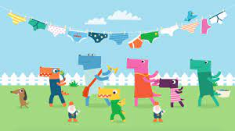  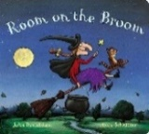  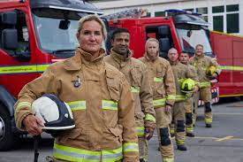  Key Stimulus: | 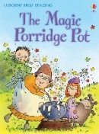  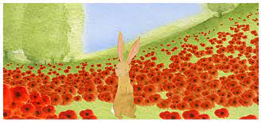  Key Stimulus: |   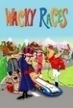  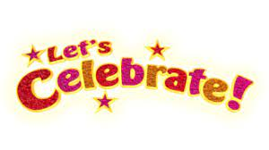  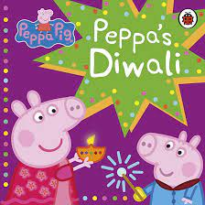  Key Stimulus: | 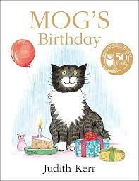  Key Stimulus:  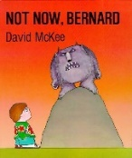 | Key Stimulus:  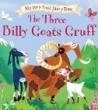 | 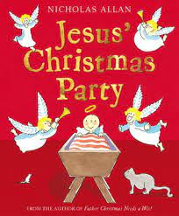  Key Stimulus:  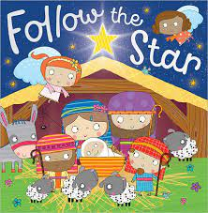 | 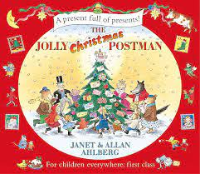  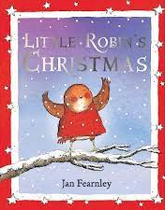  Key Stimulus:
Nursery Rhyme/Song:  Nursery Rhyme Focus | Nursery Rhyme/Song:  Nursery Rhyme Focus | Nursery Rhyme/Song:  Nativity Songs | Nursery Rhyme/Song:  Nativity Songs | Nursery Rhyme/Song:  Nativity Songs | Nursery Rhyme/Song:  Nativity Songs | Nursery Rhyme/Song:  Christmas songs
Role Play: House decorated to reflect different celebrations; Firework Night, Diwali, birthday, Christmas
C&L:
Listening, Attention & Understanding:

- Enjoys listening to longer stories and can remember much of what happens.
- Pays attention to more than one thing at a time.
- Uses a wider range of vocabulary.
- Understands a question or instructions that has two parts.
- Understands ‘why’ questions.
- Understands how to listen carefully and why listening is important.
- Learns new vocabulary
- Listens carefully to rhymes and songs
Speaking:
- Can talk about what is happening in stories.
- Sings a large repertoire of songs.
- Knows many rhymes.
- Can talk about familiar books and be able to tell a long story.
- Uses longer sentences of four to six words.
- Can express a point of view.
- Can debate when they disagree with a friend or adult, using words as well as actions.
- Starts a conversation with an adult or friend and can continue it for many turns.
- Uses talk to organise themselves and their play.
- Joins simple sentences with ‘because’, ‘or’, ‘and’.
- Begin to use a range of tenses.
- Uses new vocabulary through the day.
- Engages in story times.
- Retells stories once they’ve developed familiarity with the text.
- Asks questions to find out more and to check they understand what has been said to them
- Develops social phrases.
Listening, Attention & Understanding:  Reminder of carpet rules – legs crossed, lips closed, hands up, good looking, good listening.  Reminder of how to make a circle.  Reminder of wiggly fingers when bell/ tambourine is rung. | Listening, Attention & Understanding:  Covered through story times and new vocab linked to festivals.
Speaking:  Reminders to speak in full sentences with our friends and ask somebody if we can play with them.  Reminders of when and how to say please and thank you e.g. when getting our lunch. | Speaking:  Covered throughout other areas of learning.

PSED:
Self-Regulation:

- Become more outgoing with unfamiliar people in the setting.
- Sees themselves as a valuable individual
- Express their feelings
Managing Self:
- Beginning to remember rules without needing an adult to remind them.
- Talks about their feelings using words like ‘happy’, ‘sad’, ‘angry’ or ‘worried’.
- Begins to understand how others may be feeling.
- Be increasingly independent when dressing, undressing and meeting their own care needs
- Make healthy choices about food, drink, activity and toothbrushing
Building Relationships:
- Show more confidence in new social situations.
- Play with one or more other children, extending and elaborating play ideas.
- Talk with others to solve conflicts
- Build constructive and respectful relationships
Jigsaw PSHE:
- I can identify something I am good at and understand everyone is good at different things
- I understand that being different makes us all special
- I know we are all different but the same in some ways
- I can tell you why I think my home is special to me
- I can tell you how to be a kind friend
- I know which words to use to stand up for myself when someone says or does something unkind
Reminders of ‘The Golden Rules’  Reminder of zones of regulation  Introduce value of the half term | Reminders of steps when going to the toilet and when washing hands. | Covered through the day in continuous provision and with interactions with peers and staff. |  | Provide children with a ‘problem’ in the classroom. Ask them to work as a team to resolve it. E.G something is broken or the animal cannot cross the bridge – can you fix the bridge? How will you do it? What steps will you take? | Children to get undressed and dressed for Nativity show. | Covered through the day in continuous provision and with interactions with peers and staff.
PSHE- Celebrating Difference  1. What am I good at? | PSHE- Celebrating Difference  2. I’m Special, I’m Me! | PSHE- Celebrating Difference  3. Families | PSHE- Celebrating Difference  4. Homes | PSHE- Celebrating Difference  5. Making Friends | PSHE- Celebrating Difference  6. Standing Up for Yourself
Key Vocab: Different, Special, Proud, Friends, Kind, Same, Similar, Happy, Sad, Frightened, Angry, Family
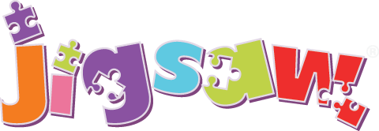
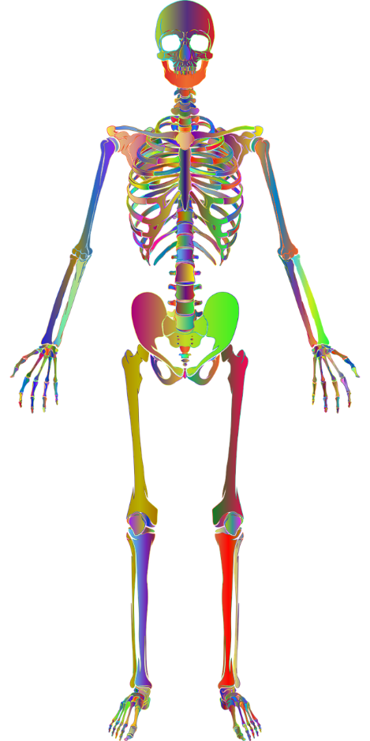
PD:
Gross Motor Skills:
- Can use scooters, trikes or bikes.
- Goes up steps/apparatus using alternate feet.
- Can skip, hop and stand on one leg.
- Can hold a pose like a statue.
- Can use large-muscle movements e.g. wave a flag or streamers.
- Takes part in some group activities which they make up for themselves or in teams.
- Can remember sequences and patterns of movement related to music and rhythm
- They can decide how they travel along apparatus based on their developing physical skills.
- Can choose appropriate resources to carry out a plan.
- Works with others to manage large items e.g. carrying a plank with a friend.
- Demonstrates the ability to roll, crawl, walk, jump, run, hop, skip and climb.
- Use their core muscle strength to achieve a good posture when sitting at a table or on the floor.
- Develop the overall body strength, co-ordination, balance and agility
- Develop a range of ball skills including throwing and catching
Fine Motor Skills:
- Uses one-handed tools and equipment
- Uses a comfortable grip with good control for holding pens/pencils.
- Start to eat independently and learning how to use a knife and fork
- Shows a preference for a dominant hand.
- Becomes more independent as they get dressed/undressed.
- Can use a range of tools competently, safely and confidently.
Get Set 4 P.E:
- Negotiates space safely with consideration for myself and others.
- Confidently and safely uses a range of large and small apparatus.
- Combines movements, selecting actions in response to the task and apparatus.
- Uses movement skills with developing strength, balance and co-ordination showing increasing control and grace.
Gross Motor:  Introduce balance bikes into outdoor area.  Continue teaching how to do zip on our coat. | Gross Motor:  Covered in PE lessons and through continuous provision and independent access to resources.
Fine Motor:  Introduce pasta threading to fine motor area | Fine Motor:  Introduce buttons and patterns to fine motor area | Fine Motor:  Introduce tap-tap shapes to fine motor area | Fine Motor:  Children to have access to fine motor area through continuous provision
PE:  Gymnastics Unit 2  Theme: Jack and the Beanstalk  To create short sequences using shapes, balances and travelling actions. | PE:  Gymnastics Unit 2  Theme: Jack and the Beanstalk  To develop balancing and safely using apparatus. | PE:  Gymnastics Unit 2  Theme: Jack and the Beanstalk  To develop jumping and landing safely from a height. | PE:  Gymnastics Unit 2  Theme: Goldilocks and the Three Bears  To develop rocking and rolling. | PE:  Gymnastics Unit 2  Theme: Goldilocks and the Three Bears  To explore travelling around, over and through apparatus. | PE:  Gymnastics Unit 2  Theme: Goldilocks and the Three Bears  To create sequences using apparatus.

Key Vocab: copy, over, travel, around, space, shape, through, roll


Literacy:
Word Reading:
- Can spot and suggest rhymes.
- Counts or claps syllables in words.
- Recognises words that have the same initial sound.
- Reads individual letters by saying the sounds for them.
- Blends sounds into words so they can read short words.
- Reads some digraphs.
- Read a few CEWs matched to Monster Phonics
- Reads simple phrases and sentences.
Comprehension:
- Understands that print has meaning.
- Understands that print has different purposes e.g. to warn.
- Knows that we read English from left to right and top to bottom.
- Can name the different parts of a book.
- Knows that pages are sequenced.
- Engages in extended conversations about stories.
- Discusses vocabulary in texts.
- Re-reads books to build up their confidence in word reading, their fluency and their understanding and enjoyment.
Writing:
- Uses some print and letter knowledge in their early writing e.g. writing a shopping list that starts at the top of the page or writing ‘m’ for mummy.
- Writes some or all of their name.
- Writes some letters accurately.
- Form lower-case letters correctly.
Word Reading:  Monster Phonics  h,b  HFWs: up, mum, put, has, had, him, his, oh, big | Word Reading:  Monster Phonics  f,ff,l,ll,ss  HFWs: he, she, me, we, be, of | Word Reading:  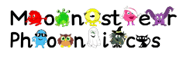  Monster Phonics Assessment Week | Word Reading:  Monster Phonics  j,v,w,x  HFWs: if, off, you, my, they, for, going | Word Reading:  Monster Phonics  y,z,zz,qu  HFWs: was, will, all, went, from, help | Word Reading:  Monster Phonics  ch,sh,th,ng  HFWs: too, her, with, are, yes | Word Reading:  Monster Phonics Assessment Week
Comprehension:
Covered through story times

Writing:  Children to write their name for their learning space | Writing:  Writing opportunities available in continuous provision |  | Writing:  Writing opportunities available in continuous provision- Birthday Invitations | Writing:  Writing opportunities available in continuous provision | Writing:  Children to write their Christmas cards | Writing:  Writing opportunities available in continuous provision Old Christmas Cards
Drawing Club:  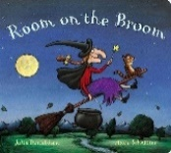  Key Stimulus:  Vocabulary:  WHOOSH  SPLAT  SCALY  HORRIBLE  PASSENGER  ADDITION  FIERY  SWOOP | 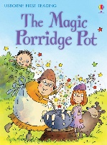  Drawing Club:  Key Stimulus:  Vocabulary:  ENCHANTED  CONVERSATION  ENDLESS  DESPAIR  CEASE  COVERED  STEAMING  GLOOPY | 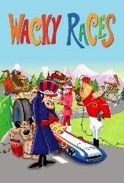  Drawing Club:  Key Stimulus:  Vocabulary:  ACCELARATE  BREAKING  HAZARD  STEERING  CHUCKLE  DEMLISH  OVERTAKE  TRANSPORT | Drawing Club:  Key Stimulus:  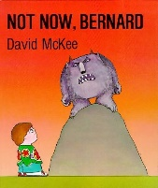  Vocabulary:  GOBBLE  DESTROY  IGNORE  FIERSOME  CHOMP  LEAKING  SPLATTER  ASTONISHED | Drawing Club:  Key Stimulus:  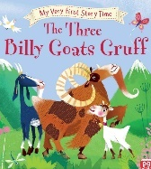  Vocabulary:  LUSCIOUS  TRIPLE  CREAKY  FEARLESS  GRUESOME  SUDDENLY  DETERMINED  BAMBOOZLE |  | 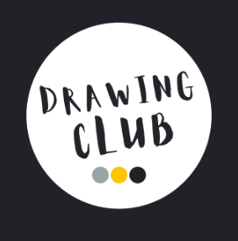

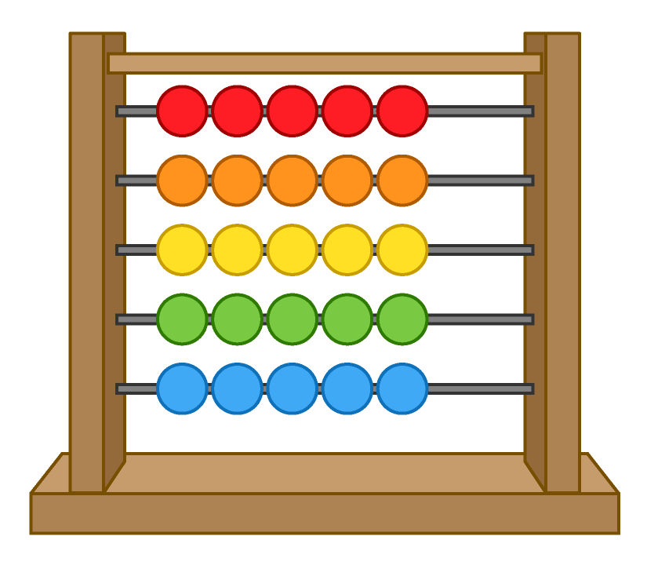
Maths:
Number:
- Develops fast recognition of up to 3 objects, without having to count them individually (subitising)
- Says one number for each item in order.
- Knows that the last number reached when counting tells how many in total (cardinal principles).
- Links numerals and amounts.
- Experiments with their own symbols and marks as well as numerals.
- Solve real world mathematical problems with numbers up to 5.
- Count objects, actions and sounds up to 5
- Can automatically recall number bonds to 5.
- Understands one more than/one less than up to 5
- Compare numbers up to 5
- Compares two small groups of up to five objects, saying when there are the same number of objects in each group
- Compare quantities using ‘more than’ and ‘fewer than’.
Shape, Space & Measures:
- Talk about and explore ‘2D’ shapes using informal and mathematical language e.g. sides, corners, straight, flat, round.
- Understand position through words and without pointing.
- Identify and name circles and triangles.
- Compare circles and triangles.
- Identify shapes in the environment.
- Describe position.
- Identify and name shapes with 4 sides.
- Select, rotate and manipulate shapes in order to develop special reasoning skills.
- Compose and decompose shapes so that children recognise a shape can have other shapes within in it, just as numbers can.
Maths:  Block 4 - Circles and triangles  - Identify and name circles and triangles  - Compare circles and triangles  - Shapes in the environment  - Describe position | Maths:  Block 5 - 1,2,3,4,5  - Find 4 and 5  - Subitise 4 and 5  - Represent 4 and 5  - 1 more  - 1 less  - Composition of 4 and 5  - Composition of 1-5 | Maths:  Block 6 - Shapes with 4 sides  - Identify and name shapes with 4 sides  - Combine shapes with 4 sides  - Shapes in the environment  - My day and night |  | Consolidation
Linked Texts:  - Circle, Triangle, Elephant! A Book of Shapes and Surprises by Kenji Oikawa and Mayuko Takeuchi  - Triangle by Mac Barnett and Jon Klassen  - Shapes, Shapes, Shapes by Tana Hoban  - We’re Going on a Bear Hunt by Michael Rosen  - Rosie’s Walk by Pat Hutchins  Linked Rhymes:  - My Hat, It Has Three Corners | Linked Texts:  - Witches Four by Marc Brown  - Five Little Fiends by Sarah Dyer  - Pete the Cat and his Four Groovy Buttons by Eric Litwin  - Kipper’s Birthday by Mick Inkpen  - The Very Hungry Caterpillar by Eric Carle  - Stella to Earth! By Simon Puttock and Philip Hopman  - Anno’s Counting Book by Mitsumasa Anno  Linked Rhymes:  - 1,2,3,4,5 Once I Caught a Fish Alice  - One Man Went to Mow  - Five Currant Buns  - Five Little Men in a Flying Saucer  - Five Little Speckled Frogs  - Five Little Teddy Bears |  | Linked Texts:  - Bear in a Square by Stella Blackstone  - Square by Mac Barnett and Jon Klassen  - Shapes, Shapes, Shapes by Tana Hoban  - Night Monkey, Day Monkey by Julia Donaldson  - The Fox in the Dark by Alison Green  Linked Rhymes:  This Is the Way We Brush Our Teeth | 
Key Vocab:  Circle, triangle, side, corner, straight, round, flat  2-D | Key Vocab:  One, two, three, four, five, total, altogether, subitise, count, how many |  | Key Vocab:  Squares, rectangles, sides, corners, equal, 2-D, same, different


UOW:
Past and Present:
- Beginning to understand their own life-story and family’s history.
- Can talk about the features of the current season.
- Comment on images, stories, artefacts and accounts from the past.
- Can talk about members of their family.
- Knows that there are different types of families.
- Can name and describe people who are familiar to them.
- Understands how to explore the world around them.
- Able to recognise that things happened before they were born.
People, Culture and Communities:
- Develops positive attitudes about the differences between people
- Knows that there are different countries around the world and that we live in England.
- Understands that some places are special to their community.
- Knows there are different types of families
The Natural World:
- Explores natural materials.
- Talks about collections of natural materials.
- Can talk about what they see using a wide vocabulary.
- Explore the natural world around them.
- Knows the name of the road the school is to and which town the school is in.
UOW:  Natural resources added to the loose parts area for the children to explore. | UOW:  Cbeebies remembrance video. Why do we wear poppies? | UOW:  Talk about Diwali and why this is an important celebration for Hindus  (Parent in if possible) | UOW:  Talk about birthdays. Do the children know when their birthday is? Celebration board. Link to R.E | UOW:  Learn the Nativity Story | UOW:  Learn that School in on Barley Mow Road, the post box is on Harvest Road. Children to know what road they live on.  Look at maps of route to post box. Children to draw their own map | UOW:  Recap the Nativity Story
RE:  Remind about reflection area and how we can use it. Learn the home time prayer. |  | RE: Why do we have celebrations?  Parent in to talk about Diwali  Engage | RE: Why do we have celebrations?  Talk about birthdays  Explore | RE: Why do we have celebrations?  Talk about how Christmas is (or isn’t) celebrated in our homes.  Evaluate | RE: Why do we have celebrations?  Look at photos from post box walk. Look for signs that Christmas is coming - Evaluate
Key Vocab: Birthday, Gift/present, Celebration, Decoration, Thank you, Wedding, Christmas, Easter, Harvest, Diwali, Ramadan, Eid, Chinese New Year, Jewish Sukkot, Hanukkah, Rosh Hashanah, Journey, Christmas, Key people in the story: Jesus, Mary, Joseph, Angel, Shepherds, Kings/Wise men, Nativity, Animals’ names –sheep/donkey/camel

EAD:
Creating with Materials:

- Can use an object to represent something else.
- Begins to develop complex stories using small world equipment.
- Makes imaginative and complex small worlds using blocks and construction kits.
- Decides how to use different materials.
- Develop their own ideas and decide which materials to use.
- Joins different materials.
- Explores the use of different textures.
- Create closed shapes with continuous lines and begin to use these shapes to represent objects.
- Draws with increasing complexity and detail e.g. a face with details.
- Use drawing to represent ideas such as movement or loud noises.
- Shows different emotions in their drawings/paintings.
- Explore colour and colour mixing.
- Explore a variety of artistic effects to express their ideas and feelings.
- Knows how to mix colours successfully.
- Use different painting techniques including bubble painting, splatter painting, printing.
- Is able to represent different parts of the human body from observation, imagination or memory with attention to some detail.
- Uses clay to make a pinch pot
- Understands how to use the woodwork bench safely.

Being Imaginative and Expressive:
- Listens attentively to sounds.
- Responds to what they have heard.
- Can sing entire songs.
- Is able to match the pitch of a tone sung by another person.
- Can create their own songs.
- Listen attentively, move to and talk about music expressing their feelings and responses.
- Can develop storylines in their pretend play.
Creating with Materials:  Fireworks paintings. Children to look at Jackson Pollock paintings and create their own | Creating with Materials:  Children to create a poppy picture using either paints, pastels, collage or mixed media. Or Mini Mash | Creating with Materials:  Use clay to make a Diva lamp | Creating with Materials:  Covered throughout indoor and outdoor provision. | Creating with Materials:  Introduce junk modelling to creative area. Look at joining methods. | Creating with Materials:  Design and making Christmas cards | Creating with Materials:  Opportunities to make Christmas crafts, e.g. stockings, baubles, snowmen, etc
Being Imaginative:
Covered throughout indoor and outdoor provision
Music: Charanga  My Stories - Step 1 | Music: Charanga  My Stories - Step 2 | Music: Charanga  My Stories - Step 3 | Music: Charanga  My Stories - Step 4 | Music: Charanga  My Stories - Step 5 | Music: Charanga  My Stories - Step 6
Key Vocab: colour, draw, paint, paper, scissors, glue, chalk, pencil, pen, red, blue, yellow, green, orange, purple, pink, playdough, cut, line, circle, music, listen, sing, clap, tap, bang, shake, play, loud, quiet, fast, slow, whisper, high, low, long, short, pulse, dynamics, tempo, solo, duet, choir, rhythm, bongo tubes, tambourine, drum.


